**GASABO DISTRICT**

**DISTRICT COMPREHENSIVE ASSESSMENT, RTQF LEVEL… 2022-2023**

**TRADE:NETWORKING AND INTERNET TECHNOLOGY………………………………**

**MODULE: ELECTRONICS FUNDAMENTALS……………………………**

**DATE OF EXAM: ………………………… Duration: 3 hours………….**

**ACADEMIC YEAR: 2022-2023**

**Instructions:**

1. **Answer all questions in section A (55 Marks)**
2. **Answer three question in section B (30 Marks)**
3. **Answer one question in section c (15 Marks**)

**I SECTION A ANSWER ALL QUESTIONS(55marks)**

Q1.Define /3marks

a) Resistor

b)Diode

c)Voltage multiplier

Q2.Give difference between capacitor and inductor/2marks

Q3.Explain more these terms/3marks a.insulator

b.inductor

c.semi conductor

Q4.state Ohm's law/1.5marks

Q5. The wire's length and area are 0.2 m and 0.5m2, respectively. Calculate the resistivity of that wire whose resistance is 3 Ω. /5marks

Q6.Match given diodes to where it is used using table below:/3marks

|  |  |
| --- | --- |
| Diode | Application |
| LED |  |
| Photodiode |  |
| Rectifier diode |  |

Q7.a) Find the equivalent capacitance for below circuit/5marks

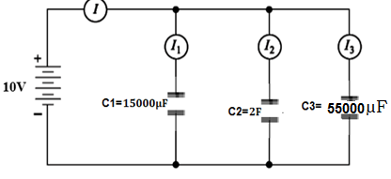

Q8.Find the total resistance for below circuit of resistors/5marks

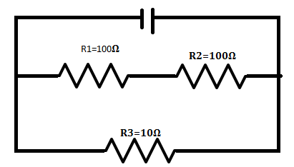

Q9.Calculate the equivalent inductance for inductor connected as below/5marks

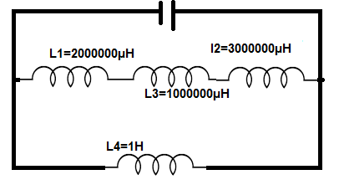

Q10.Identify 5 application of diode in photo detection/2.5marks

Q11.Identify the current in and the voltage drop across each resistor for the following circuit/5marks

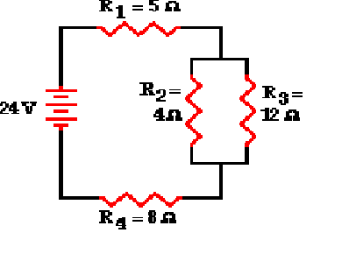

**Q12.A** 10 μF, 20 μF, 22 μF, and 100 μF capacitor are in parallel. The total capacitance is/**2marks**

1. 2.43 uF
2. 4.86 uF
3. 100 uF
4. 152 uF

**Q13** What are the two types of BJT Transistor/2marks

**Q14**.what is the formula of frequency?/3marks

**Q15**.Compare fixed resistor to variable resistor/3marks

**II.SECTION B CHOOSE 3 QUESTIONS(30marks)**

**Q16**.Three inductors of 60mH, 120mH and 75mH respectively, are connected together in a parallel combination with no mutual inductance between them. Calculate the total inductance of the parallel combination in millihenries (mH)/10marks.

**Q17**.Figure below shows that a silicon transistor with β = 100 is biased by base resistor method. Draw the d.c. load line and determine the operating point. /10marks

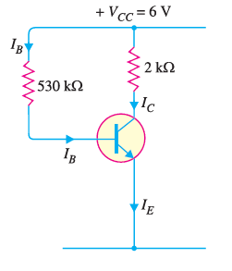

**Q18.**Find the total capacitance of the combination of capacitors shown in Figure below. Assume the capacitances in the given Figure are known: (C1 = 1 µF, C2 = 5 µF, and C3 = 8 µF) /7marks

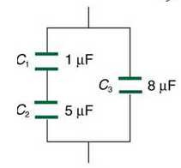

**Q19.**In the circuit diagram shown in Fig. (i), if VCC = 12V and RC = 6 k, draw

the d.c. load line. What will be the Q point if zero signal base current is 20μA and β= 50 ?/10 marks

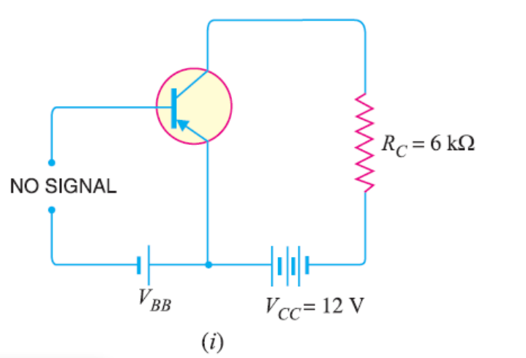

**Q20.** list list 5 **Advantages of FETs and BJT/10marks**

**III. SECTION C SHOOSE 1 QUESTION(15marks)**

**Q21**.For a transistor, β= 45 and voltage drop across 1kῼ which is connected in the

collector circuit is 1 volt. Find the base current for common emitter connection /15marks

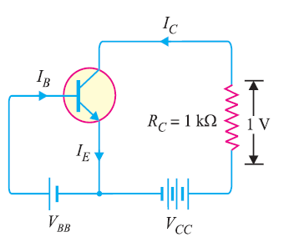

**Q22**.For common base circuit.determine IC and VCB. Assume the transistor to be of silicon. /15marks

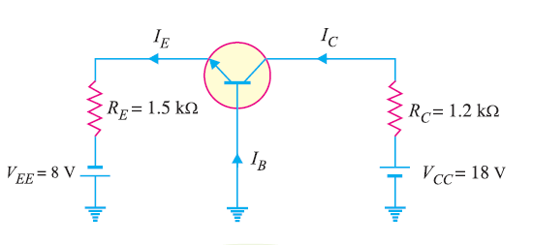

**GOOD LUCK**